STUDENT LESSON

AB30 – Binary Search Trees
Student LESSON

AB30 – Binary Search Trees

INTRODUCTION: A binary tree is a different kind of data structure that demands new terminology and algorithms. A binary tree node will have two pointers available for linking with other nodes, resulting in diagrams that look like inverted trees. A binary tree will begin with one node at the top and branch out below. As you might expect, the potential of going one of two different ways leads to some challenging programming problems. In fact, the idea of trying one direction and then backtracking naturally leads to recursion.

The key topics for this lesson are:

A. Binary Tree Vocabulary
B. Building a Binary Tree
- Shape of a Binary Tree
D. Inorder Tree Traversal
E. Preorder and Postorder Tree Traversals
F. Counting the Nodes in a Tree
- Searching a Binary Tree
H. Deletion from a Binary Tree
I. deleteTargetNode Method

VOCABULARY: BINARY TREE CHILD NODE
EDGE INORDER
LEAF LEVELS
PARENT NODE POSTORDER
PREORDER ROOT NODE
SUBTREE TREE TRAVERSAL
VISITING A NODE

DISCUSSION: A. Binary Tree Vocabulary

1. A binary tree is a data structure where each node has two pointers, each pointing to another node or containing a null value.
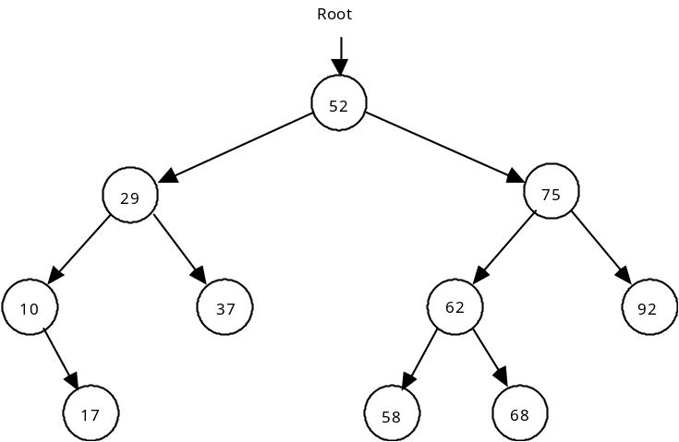

2. The following binary tree terms will be defined and applied to the above example.

a. Root node - the top node in the tree; the node whose value is 52.

b. Parent node - a node that points to one or two nodes below it.

c. Child node - the node being pointed to by a parent; every node in the tree is a child to another node, except for the root node.

d. Leaf - a node that has no children

e. Level - the distance from the root, calculated by counting the shortest distance from the root to that node. Examples: 29 is stored in a node at level 1, 62 is stored in a node at level 2, 17 is stored at level 3, etc.

f. Edge - an edge joins two nodes. In the above diagram, each arrow represents an edge.

3. This tree is an example of an ordered binary tree that has the following property. For every parent node, a child to the right will have a larger value, while a child to the left will have a smaller value.

4. A subtree is the entire left branch or right branch of a node. For example, the left subtree of the node containing 52 has 4 nodes. The right subtree of node containing 75 has only 1 node.

5. A leaf will have two null pointers.

B. Building a Binary Tree

1. The following definition of a TreeNode class will be used in the remainder of this section on building a binary tree.

public class TreeNode{
private Object value;
private TreeNode left;
private TreeNode right;

public TreeNode(Object initValue, TreeNode initLeft,
TreeNode initRight) {
value = initValue;
left = initLeft;
right = initRight;
}
public Object getValue(){
return value;
}

public TreeNode getLeft(){
return left;
}

public TreeNode getRight(){
return right;
}

public void setValue(Object theNewValue) {
value = theNewValue;
}

public void setLeft(TreeNode theNewLeft) {
left = theNewLeft;
}

public void setRight(TreeNode theNewRight) {
right = theNewRight;
}
}

2. Suppose the following integers were inserted into a sorted binary tree in the indicated order.

26 79 14 99 53 9 35 21 87

Draw the resulting binary tree.

26
- 99
9 21 53
35 87
See Transparency AB30.1, Building a Binary Tree | 3. You will notice that as each node was added to the tree, it was inserted as a leaf. The insert algorithm will be recursive.
4. Given this parameter list for the insert method, develop the pseudocode below it.

void insert (TreeNode node, Object data)
// Will insert data into an ordered binary tree.
// The solution is recursive.

C. Shape of a Binary Tree

1. The shape of a binary tree will affect its performance as a data structure and is dependent on the initial order of the data set used to build the tree.

2. If the data set is already sorted (1 2 3 4...), the binary tree is essentially a linked list with an unused left pointer in each node.

3. A data set in random order will lead to a more balanced tree.

- Ideally, we want binary trees that are balanced with almost equal numbers of nodes in each subtree of every node. A balanced binary tree is defined as follows:
For every node in the tree, the number of nodes in its left subtree is equal to the number of nodes in its right subtree, plus or minus one.
Please note: Balancing binary trees will not be covered in this curriculum.

D. Inorder Tree Traversal

1. At first glance, printing out the information in a binary tree, in ascending order, does not appear to be a simple task. The example diagram in Transparency AB30.1, Building a Binary Tree illustrates that the first node value printed should be 9, and getting there is fairly simple. The next value is 14, then 21. Then, there's a major issue - how do we get back to the root node whose value is 26? This is a backtracking problem that is elegantly solved using recursion.

2. A tree traversal is an algorithm that visits every node in the tree. To visit a node means to process something regarding the data stored in the node. For now, visiting the node will involve printing the value object field.

3. An inorder tree traversal visits every node in a certain order. Each node is processed in the following sequence.

- Traverse the left subtree inorder
- Visit node
- Traverse the right subtree inorder

Notice that actually visiting the node occurs between the two recursive calls.

4. Here is the code for the inorder method.

void inorder (TreeNode temp) {
if (temp != null) {
inorder (temp.getLeft());
System.out.println(temp.getValue());
inorder (temp.getRight());
}
}

5. To see how the method, inorder works, study the following table:

Step | Current Node Value
inorder is passed the root node | 26
inorder is passed the left subtree of 26 | 14
inorder is passed the left subtree of 14 | 9
inorder is passed the left subtree of 9 | null
Output 9 | 9
inorder is passed the right subtree of 9 | null
Output 14 | 14
inorder is passed the right subtree of 14 | 21
inorder is passed the left subtree of 21 | null
Output 21 | 21
inorder is passed the right subtree of 21 | null
Output 26 | 26
inorder is passed the right subtree of 26 | 79
Continue processing

E. Preorder and Postorder Tree Traversals

1. A preorder tree traversal processes each node in a different order.

- Visit the node
- Process the left subtree preorder
- Process the right subtree preorder

The only difference is that we visit the root first, then go left, then right. The preorder output of the same binary tree will be:

26 14 9 21 79 53 35 99 87

2. A postorder tree traversal has this order:

- Process the left subtree postorder
- Process the right subtree postorder
- Visit the node

The prefix “post” refers to after, hence the location of visiting the node after the recursive calls. The printout of the same tree will be as follows:

9 21 14 35 53 87 99 79 26

F. Counting the Nodes in a Tree

1. A standard binary tree algorithm is to count the number of nodes in the tree. Here is a pseudocode version.

- Count the left subtree recursively
- Count the current node as one
- Count the right subtree recursively

2. As you develop the code, consider what base case will terminate the recursion.

G. Searching a Binary Tree

1. Searching an ordered binary tree can be solved iteratively or recursively. Here is the iterative version:

TreeNode find(TreeNode root, Comparable valueToFind) {
TreeNode node = root;

while (node != null) {
int result = valueToFind.compareTo(node.getValue());
if (result == 0)
return node;
else if (result < 0)
node = node.getLeft();
else // if (result > 0)
node = node.getRight();
}
return null;
}

2. If the value is not in the tree, the node pointer will eventually hit a null.

3. Notice the type of the argument, valueToFind, in the find method is designated as Comparable. find’s code calls the compareTo method of the valueToFind object to determine the ordering relationship. We declare valueToFind as a Comparable, not just an Object to guarantee that it will have a compareTo method.

4. A recursive version is left for you to implement as part of Lab Assignment AB30.2, BS Tree continued.

5. The order of searching an ordered binary tree is O(log2N) for the best case situation. For a perfectly balanced tree, the capacity of each level is 2level #.

Level # Capacity of Level Capacity of Tree

0 1 1
1 2 3
2 4 7
3 8 15
4 16 31
5 32 63
etc.

- So starting at the root node, a tree of 63 nodes would require a maximum of 5 left or right moves to find a value. The number of steps in searching an ordered binary tree is approximately O(log2N).

H. Deletion from a Binary Tree

1. Deleting a node involves two steps:
a. Locating the node to be deleted.
b. Eliminating that node from the data structure.

2. After locating the node to be deleted, we must determine the nature of that node.

a. If it is a leaf, make the parent node point to null.
b. If it has one child on the right, make the parent node point to the right child.
c. If it has one child on the left, make the parent node point to the left child.
d. If it has two children, the problem becomes much harder to solve.
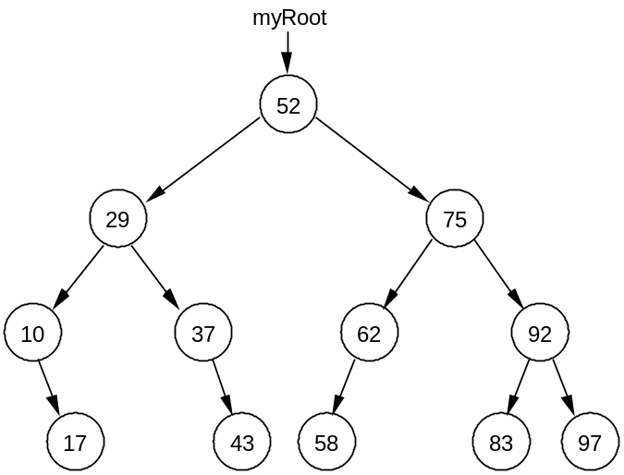

Diagram 30-1

3. The leaf node containing the value 43 will be easy to delete. The parent node of the node containing 43 will change its right pointer to null.

4. Deleting a node with one child on the right, like the node with value 10, will involve rerouting the node from its parent to its single right child.

5. But deleting the node with value 29, a node with two children, involves breaking off subtrees and reattaching them at the proper location.

See Handout AB30.1, Deletion from a Binary Tree | 6. The code to implement deletion from a binary tree is given in Handout AB30.1, Deletion from a Binary Tree. The recursive deleteHelper method that locates the node to be deleted is given below:

public void delete(Comparable target){
myRoot = deleteHelper(myRoot, target);
}

private TreeNode deleteHelper(TreeNode node, Comparable target){
if (node == null) {
throw new NoSuchElementException();
}
else if (target.equals(node.getValue())){
return deleteTargetNode(node);
}
else if (target.compareTo(node.getValue()) < 0)
node.setLeft(deleteHelper(node.getLeft(), target));
return node;
}
else{ //target.compareTo(root.getValue()) > 0
node.setRight(deleteHelper(node.getRight(), target));
return node;
}
}

7. The delete method passes the root of the tree (myRoot) and the target item to be located to the deleteHelper method. The deleteHelper method receives a TreeNode reference alias (node). The deleteHelper method has 4 scenarios:

a. node == null, the value does not exist in the tree, throw a NoSuchElementException.
b. We found the correct node (target.equals(node.getValue())), call deleteTargetNode and pass it node.
c. Did not find the node yet, recursively call deleteHelper and pass it the internal reference to the left child.
d. Recursively call deleteHelper and pass it the internal reference to the right child.
I. deleteTargetNode Method

1. The deleteHelper method finds the node to be deleted and calls removeTargetNode, passing a reference to the TreeNode target as shown in the following method:

private TreeNode deleteTargetNode(TreeNode target){
if (target.getRight() == null) {
return target.getLeft();
}
else if (target.getLeft() == null) {
return target.getRight();
}
else if (target.getLeft().getRight() == null) {
target.setValue(target.getLeft().getValue());
target.setLeft(target.getLeft().getLeft());
return target;
}
else{ // left child has right child

TreeNode marker = target.getLeft();
while (marker.getRight().getRight() != null)
marker = marker.getRight();
target.setValue(marker.getRight().getValue());
marker.setRight(marker.getRight().getLeft());
return target;
}
}

2. The algorithm for deletion employed in the deleteTargetNode method is.

a. Node to be deleted has no left (or right) subtree (one child). Make the link from the parent refer to the left (or right) subtree. Note that for a leaf node the link from the parent will be set to null.

b. Node to be deleted has non-empty left and right subtrees (two children). Change the node value to the largest value in the left subtree, and then delete the largest value from the left subtree. (The deletion of the largest value must be either scenario a or b above.)

3. The leaf and one child cases are handled in deleteTargetNode as follows:

...
if (target.getRight() == null){
return target.getLeft();
}
else if (target.getLeft() == null){
return target.getRight();
}
...

These cases are left for you and your teacher to trace.
4. The two-child case is more difficult and involves changing the node value to the largest value in the left subtree, then deleting the largest value from the left subtree. The rightmost node will be the node with the greatest value in the left subtree.

5. In Diagram 30-2 below, we will work with a smaller version of the same binary tree that we used in Diagram 30-1. Here's what happens if we wish to delete the node with value 75.

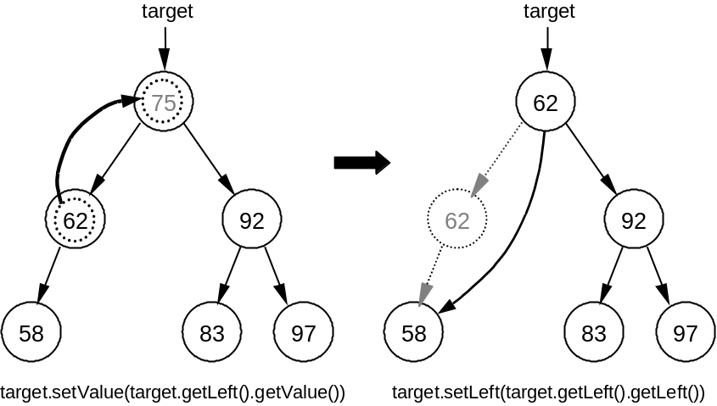

Diagram 30-2

6. Here are the steps for deleting a node having two children in which the left child has no right.

a. Copy the contents of the left child of target and set it as the current value.

target.setValue(target.getLeft().getValue());

As shown in Diagram 30-2 above, the value 75 is replaced with 62.
b. Reattach the left subtree to maintain an ordered tree. The left subtree of the node reference by target will now point to the node containing the value 58.

target.setLeft(target.getLeft().getLeft());

As shown in the Diagram 30-2 above, since the node that originally contained the value 62 is no longer referenced, it is removed (garbage collected).
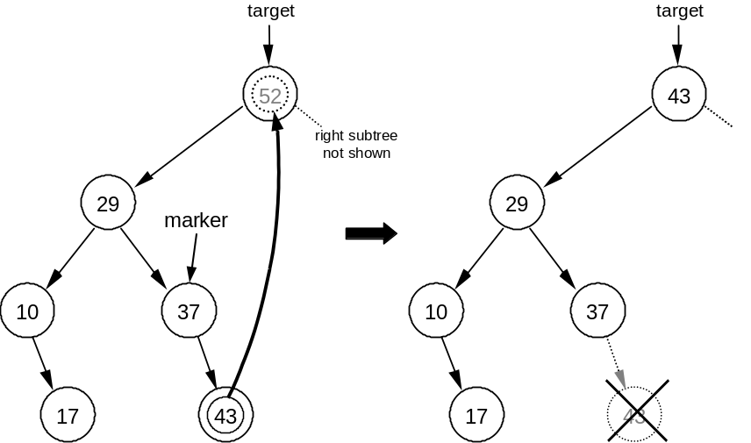

Diagram 30-3

7. In Diagram 30-3 above, we will work with the left subtree of the same binary tree that we used in Diagram 30-1. Here are the steps for deleting a node containing the value 52. In this case, the node has two children and the left child has a right child.

a. Position marker to access the node with the largest value in the left subtree. This is the rightmost node in the left subtree.

TreeNode marker = target.getLeft();
while (marker.getRight().getRight() != null)
marker = marker.getRight();

As shown in Diagram 30-3 above, marker now references the node pointing to the node with largest value in the left subtree (43).

b. Copy the contents of the right child of marker and set it as the current value.

target.setValue(marker.getRight().getValue());

As shown in Diagram 30-3 above, the value 52 is replaced with 43.
c. Delete the largest value from the right subtree. Reattach the right subtree to maintain an ordered tree.

marker.setRight(marker.getRight().getLeft());

As shown in Diagram 30-3 above, the node containing the value 43 is no longer referenced.
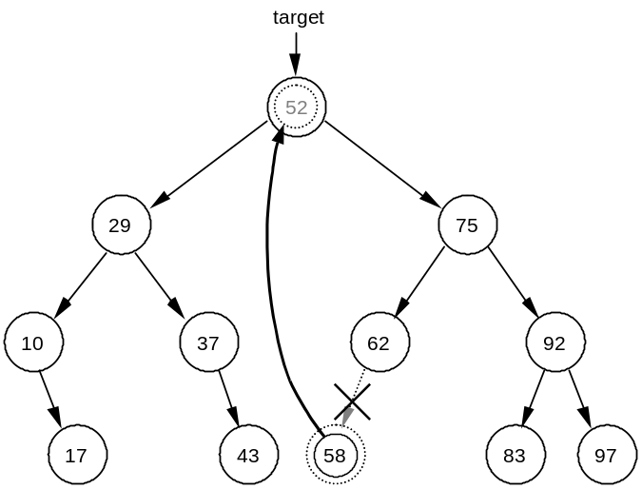

Diagram 30-4

8. This entire process for the two-child case could be directed the other way. Again, suppose the node with value 52 is to be deleted from the original tree. Referring to Diagram 30-4 above, the steps would be:

a. Access the node with the smallest value in the right subtree. This is the leftmost node in the right subtree.

b. Copy the contents (58) and set it as the current value.

c. Delete the smallest value from the left subtree. Reattach the left subtree to maintain an ordered tree.

SUMMARY/ REVIEW: | This lesson introduced the Binary Search Tree and its algorithms. The most important topic of this lesson pertains to recursive algorithms used to process binary trees. An understanding of recursive tree traversals will be attained by studying the examples and drawing lots of pictures.

ASSIGNMENT: Worksheet AB30.1, Binary Trees
Worksheet AB30.2, Recursive Tree Traversals
Transparency AB30.1, Building a Binary Tree
Handout AB30.1, Deletion from a Binary Tree
Lab Assignment AB30.1, Binary Search Tree
Lab Assignment AB30.1, Data File, file20.txt
Lab Assignment AB30.2, Binary Search Tree continued
Lab Assignment AB30.2, Data File, file20.txt
Lab Assignment AB30.3, TreeStats
Lab Assignment AB30.3, Data Files, fileA.txt, fileB.txt

